# Laboratory 2

1. Questions
   1. Write a program to read and perform addition and multiplication of two matrices of order m * n, add them and display the resultant matrix using functions.
   2. Write a program to read a string and check for palindrome without using string related function (a string is palindrome if its half is mirror by itself eg: abcdcba).
   3. Write a program to perform binary search. Use recursion.
2. Algorithm

2.1 a program to read and perform addition and multiplication of two matrices of order m * n, add them and display the resultant matrix using functions.

Step1:

Step2:

Step3:

Step4:

Step5:

Step6:

Step7:

Step8:

2.2 a program to read a string and check for palindrome without using string related function

Step1:

Step2:

Step3:

Step4:

Step5:

Step6:

Step7:

Step8:

2.3 a program to perform binary search. Use recursion.

Step1:

Step2:

Step3:

Step4:

Step5:

Step6:

Step7:

Step8:

1. Program

3.1 Program to read and perform addition and multiplication of two matrices of order m * n, add them and display the resultant matrix using functions.

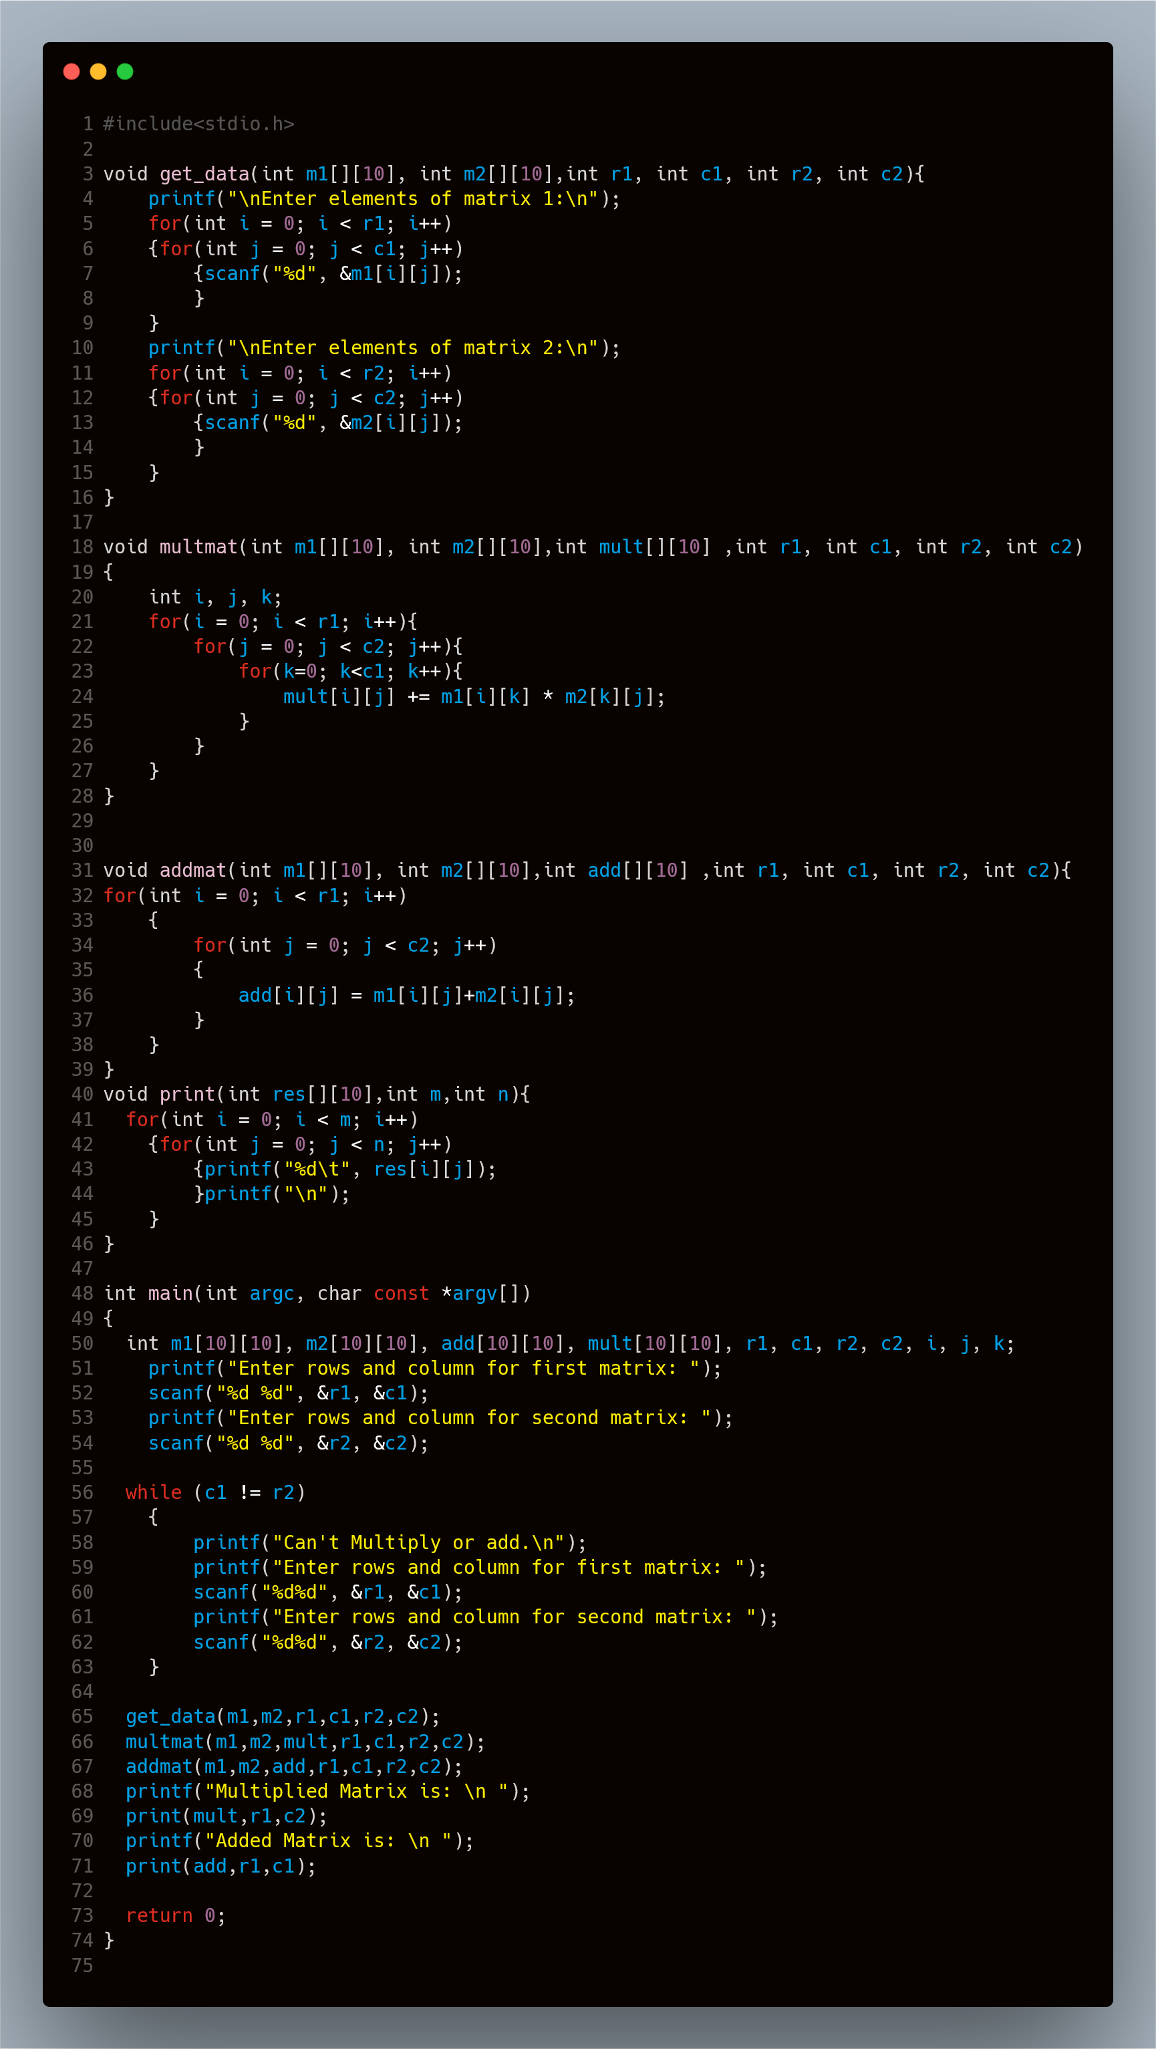

3.2 Program to read a string and check for palindrome without using string related function

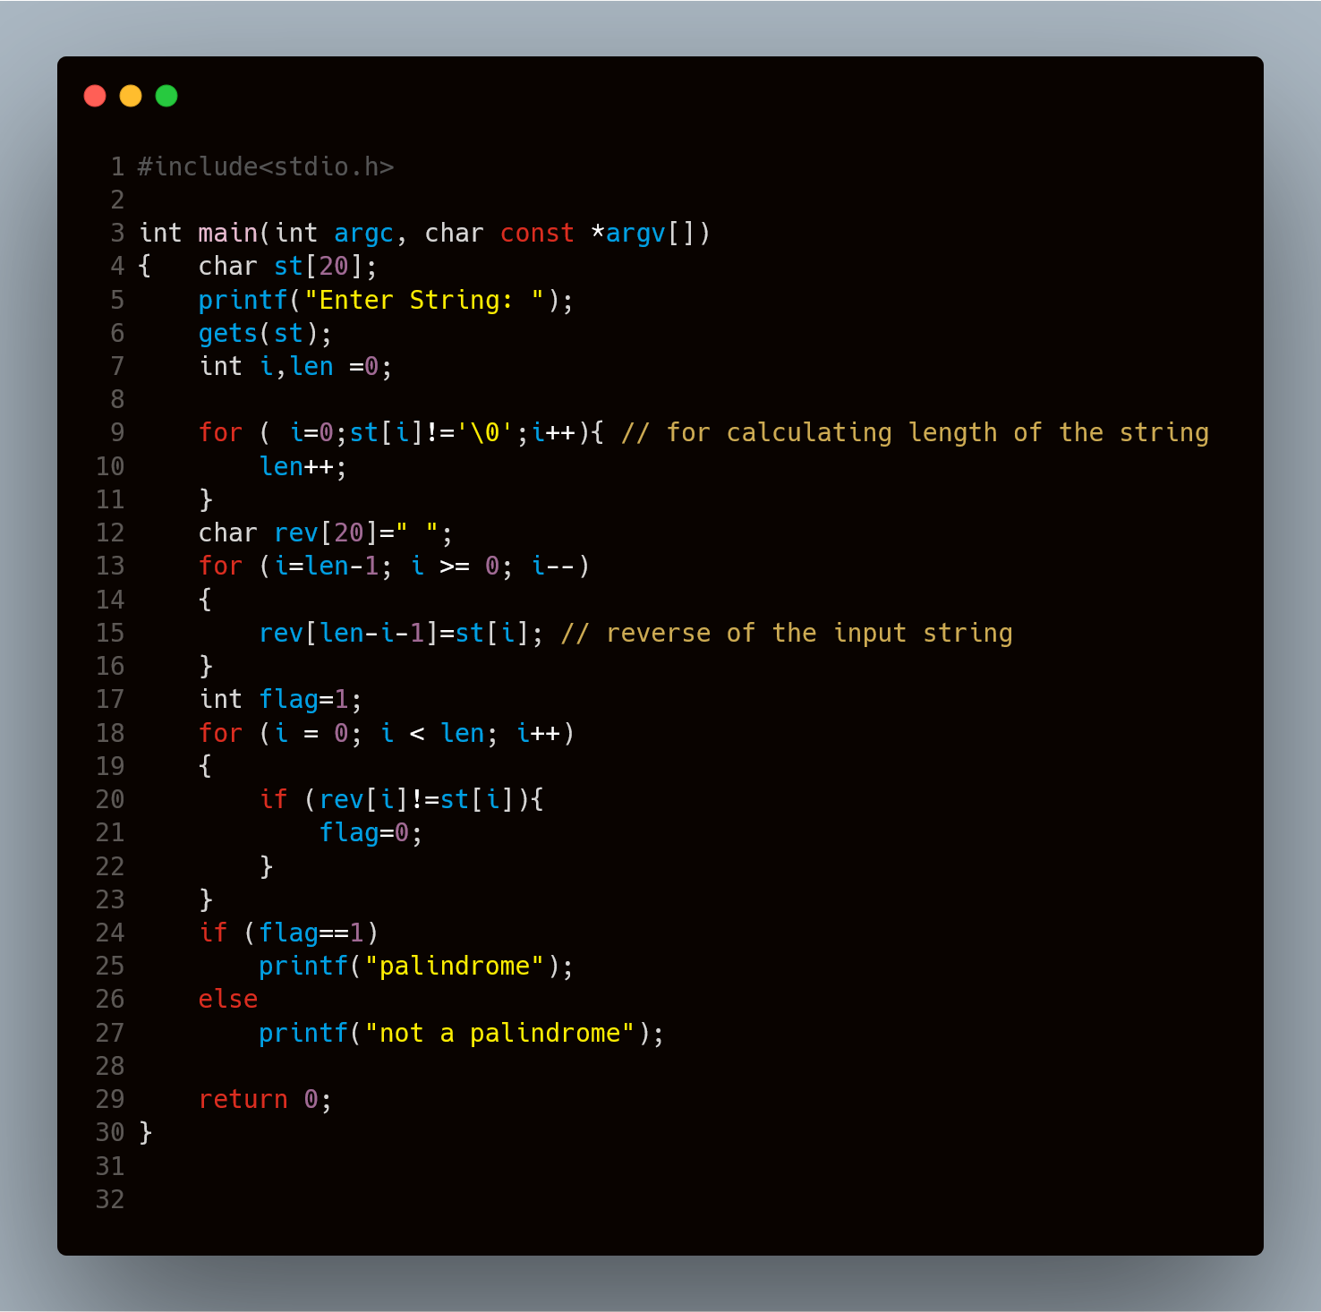

3.3 Program to perform binary search using recursion.

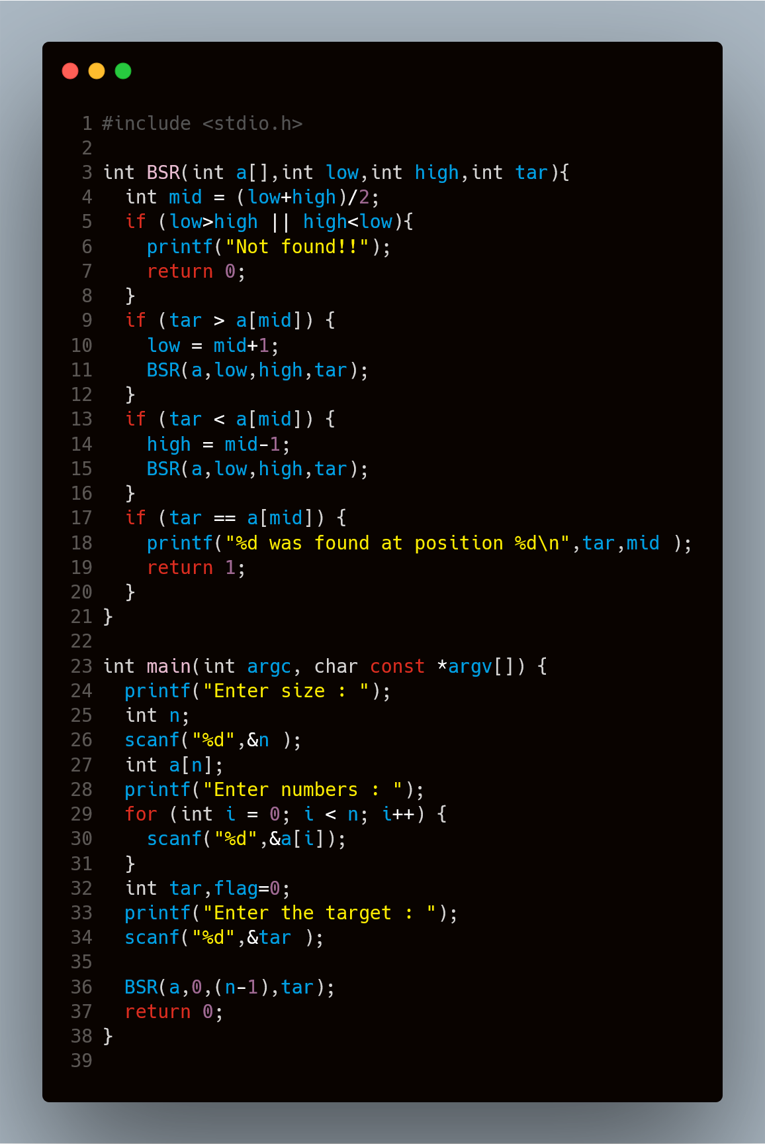

1. Presentation of Results

4.1 Program to read and perform addition and multiplication of two matrices of order m * n, add them and display the resultant matrix using functions.

4.2 Program to read a string and check for palindrome without using string related function

4.3 Program to perform binary search using recursion.

1. Conclusions

Hence we can see the programs are compiled successfully without any error.